F-51 -

Functionality
A process for transferring posted items from one Vendor’s account to another.

Scenario
The invoice posting was made on an incorrect vendor’s account. You don’t want to post a reversal, so you can make a transfer posting instead. You don’t want the invoice and the clearing document on the original account to be outstanding so they need to be cleared.

Requirements
Document (items) posted on Vendor’s account.

Menu Path | Accounting → Financial Accounting → Accounts Payable → Document entry → Other → Intern.transf.psting → F-51 - With clearing.
Transaction Code | F-51

Posting with Clearing: Header Data

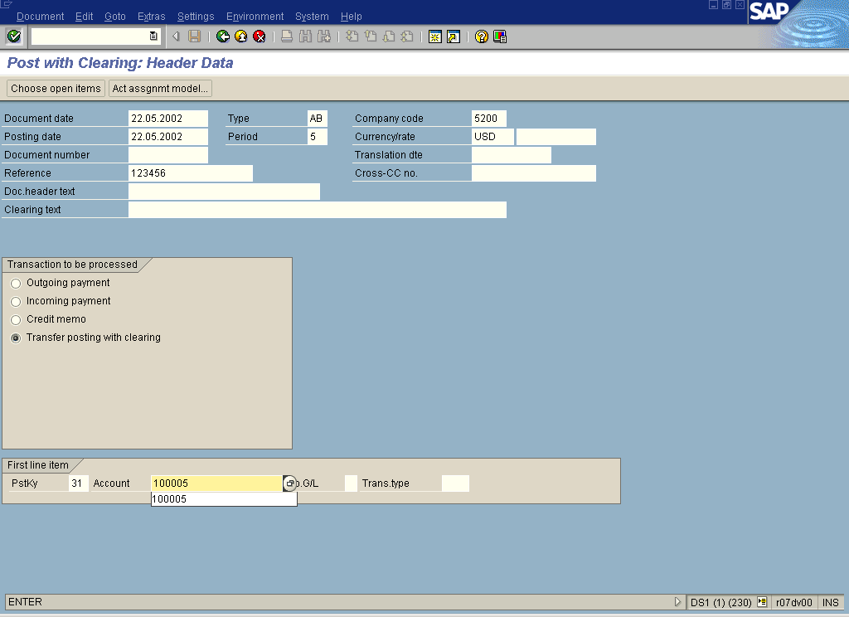

1. Update the following fields in the Document Header:

Field Name | Field Description | Values
Document date | Date the transaction occurred | Example: 22.05.2002
Document’s Type | Code identifying the accounting Document type | Example: AB
Company code | Company Code: Code identifying a separate legal entity for which a separate set of accounts is maintained for external reporting purposes | Example: 5200
Posting date | Date that the business transaction occurred | Example: 22.05.2002
Reference | Vendor document number. | Example: 123456

2. Click <radio button> Transfer posting with clearing .

3. Update the following fields for the line item:

Field Name | Field Description | Values
PstKy | Posting key | Example: 31
Account | Vendor Account for the line item to be posted. | Example: 100005

4. Click Enter .

Post with Clearing: Add Vendor item

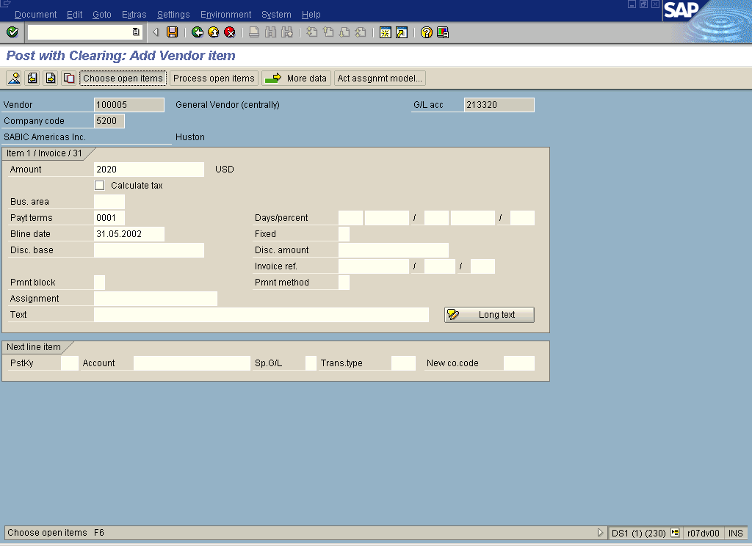

5. Update the following fields:

Field Name | Field Description | Values
Amount | Amount to be posted (in foreign or local currency). | Example: 2020
Payt terms | Payment terms to be applied to this document. | Example: 0001
Baseline Date | Baseline date for due date calculation. | Example: 31.05.2002

6. Click Choose open items Button . Now you can enter a vendor account that you want to “move” the invoice from:

Post with Clearing: Select open items

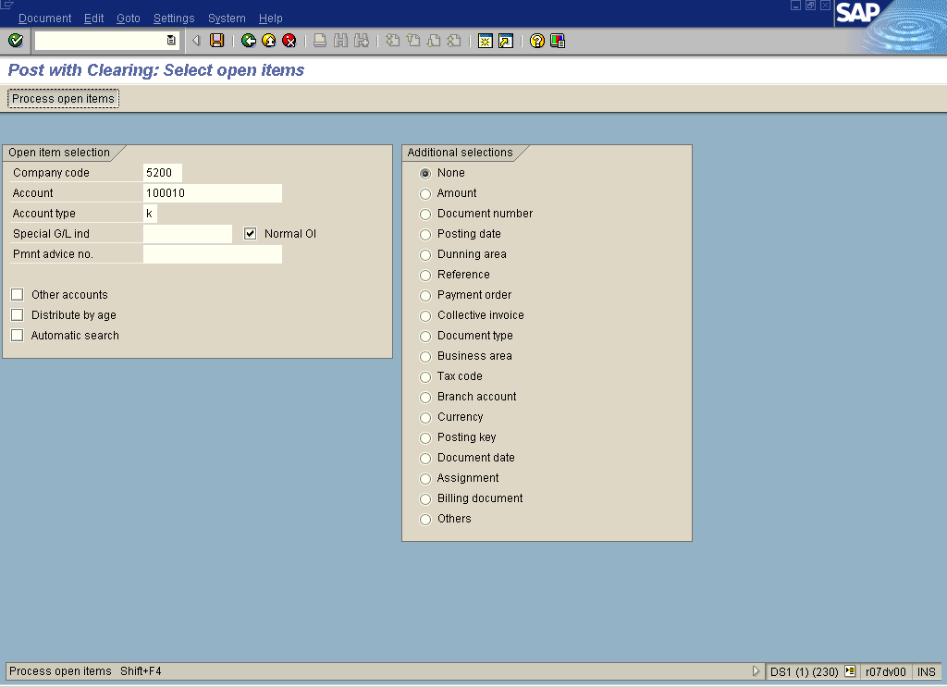

7. Update the following fields:

Field Name | Field Description | Values
Account | Code identifying the Vendor account | Example: 100010

8. Click Process open items Button . The system will display the list of open items to be cleared

Post with Clearing: Process open items

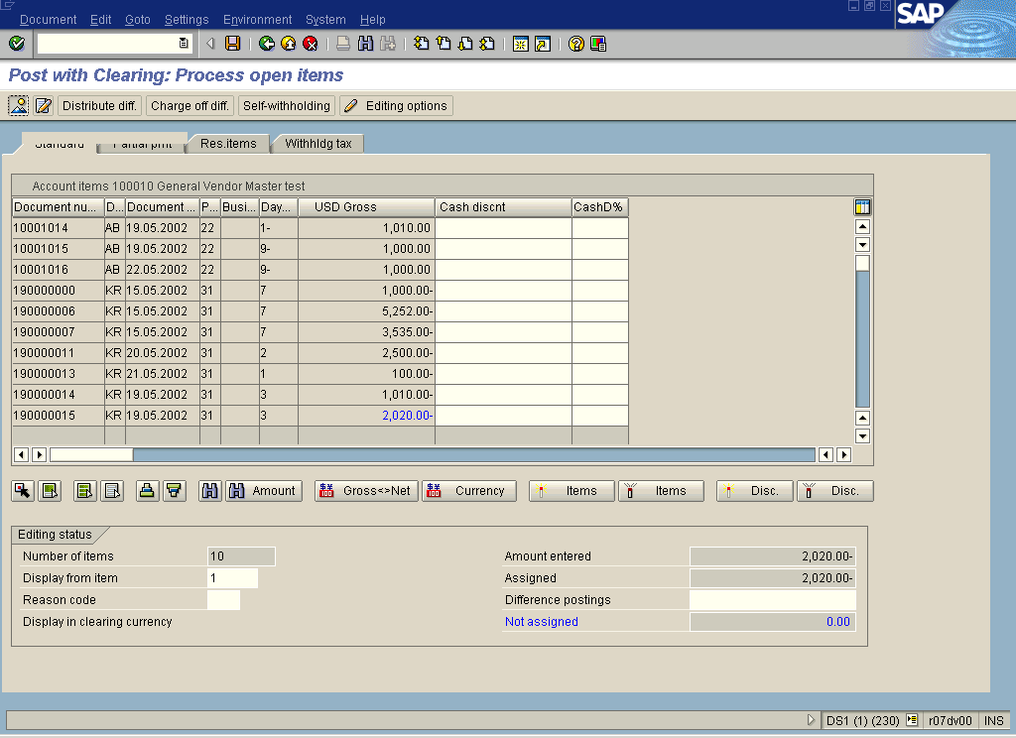

9. Mark the document/s that you want to clear (simply click on the amount)
The marked items that you want to clear will be displayed in blue color.

Tip: You can define in your user's settings whether you want all the items to be active or not active when you enter the transaction screen.

10. If the transaction amount is equal zero (field “Not assigned”) select the function DocumentSimulate.

Post with Clearing: Display Overview

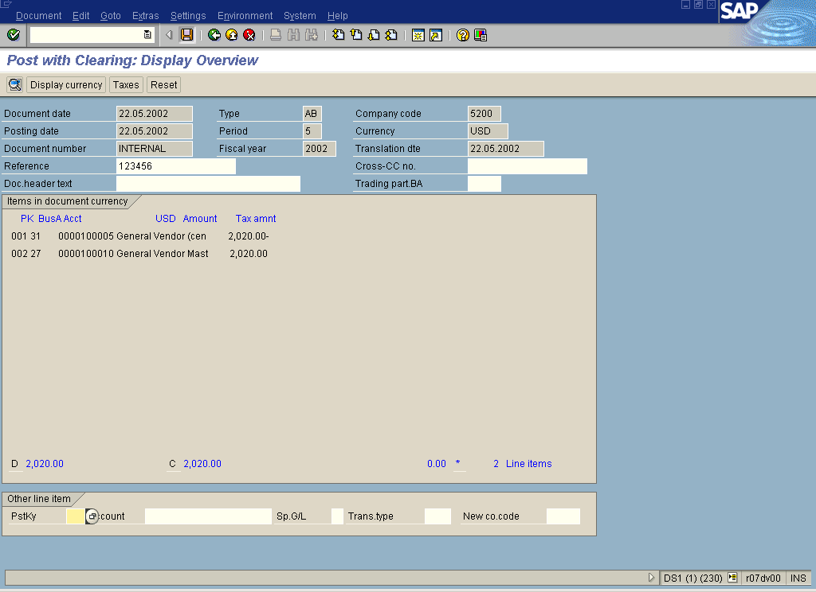

11. To post the transaction, click Save Button..
12. The document was posted. The amount of 2.020,- USD was “moved” from account 100010 and is posted as an open item on the account 100005

